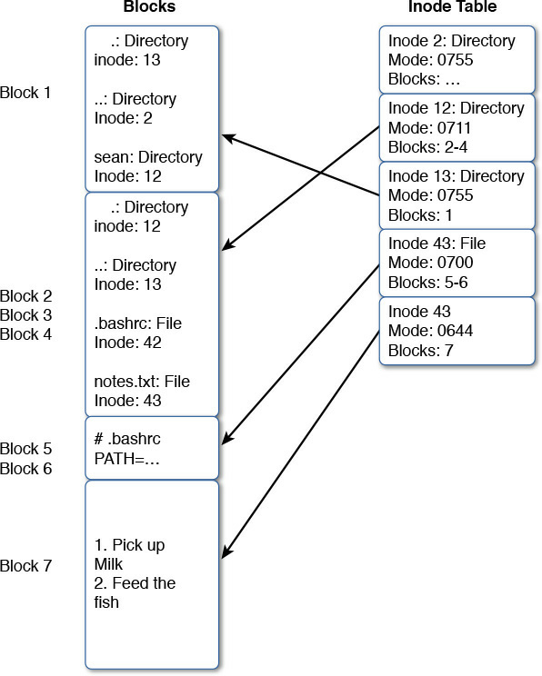

The filesystem has two structures on it. The first is the data blocks that contain the files and directories; the second is the inode table that has all the file metadata.

The first block is pointed to by inode 13. In that block are three directories: **.** is the directory itself, **..** is the parent, and sean is a subdirectory at inode 12. Looking at inode 12 you can see that it is a directory with permissions 711 with information stored in blocks 2-4. Inside those blocks is a list of subdirectories and files. The **.** and **..** directories are there along with two files. Following the inode chain for those files gets you the contents.

An important thing to take from [Figure 9-1](ch09.html#ch09fig01) is that the name of a directory is always found in its parent. Thus, being able to walk the list of inodes and directory blocks is important. The other thing to note is that there’s nothing magical about directories: They’re just a list of pointers to inodes.

This diagram also helps reinforce the difference between hard and soft links. A hard link adds a new directory entry to the inode, increasing the link count.